**Reduce the amount of push notifications require for ecommerce apps**

## A PROJECT REPORT

***Submitted by,***

**Mr. Karthik K - 20201CCS0003**

**Mr. Blesso Samuel Y -20201CCS0087**

**Mr. Dishan G S - 20201CCS0034**

**Mr. Kushal J - 20201CCS0038**

### *Under the guidance of,*

**Dr. Yashaswini K A**

***in partial fulfillment for the award of the degree of***

**BACHELOR OF TECHNOLOGY**

**IN**

**COMPUTER SCIENCE AND ENGINEERING (CYBER SECURITY)**

**At**



**PRESIDENCY UNIVERSITY**

**BENGALURU**

**JANUARY 2024**

**PRESIDENCY UNIVERSITY**

**SCHOOL OF COMPUTER SCIENCE ENGINEERING**

**CERTIFICATE**

This is to certify that the Project report **“Reduce the amount of push notifications require for e-commerce apps”** being submitted by “Karthik K, Blesso Samuel Y, Dishan G S, Kushal J” bearing roll number(s) “20201CCS0003, 20201CCS0087, 20201CCS0034, 20201CCS0038” in partial fulfilment of requirement for the award of degree of Bachelor of Technology in Computer Science and Engineering (Cyber Security) is a Bonafide work carried out under my supervision.

|  |  |
| --- | --- |
| **Dr. Yashaswini K A**  Assistant Professor-Senior Scale  School of CSE  Presidency University | **Dr. S.P. Anandaraj**  Professor & HoD  School of CSE  Presidency University |

|  |  |  |
| --- | --- | --- |
| **Dr. C. KALAIARASAN**  Associate Dean  School of CSE  Presidency University | **Dr. L. SHAKKEERA**  Associate Dean  School of CSE  Presidency University | **Dr. SAMEERUDDIN KHAN** Dean  School of CSE  Presidency University |

**PRESIDENCY UNIVERSITY**

**SCHOOL OF COMPUTER SCIENCE ENGINEERING**

**DECLARATION**

We hereby declare that the work, which is being presented in the project report entitled **Reduce the amount of push notifications require for e-commerce apps** in partial fulfilment for the award of Degree of **Bachelor of Technology** in **Computer Science and Engineering (Cyber Security)**, is a record of our own investigations carried under the guidance of **Dr. Yashaswini K A, Assistant Professor-Senior Scale,** **School of Computer Science Engineering, Presidency University, Bengaluru.**

We have not submitted the matter presented in this report anywhere for the award of any other Degree.

|  |  |
| --- | --- |
|  | **KARTHIK K -20201CCS0003**  **DISHAN G S -20201CCS0034**  **BLESSO SAMUEL Y -20201CCS0087**  **KUSHAL J -20201CCS0038** |

**ABSTRACT**

One of the most significant subcategories of general notifications is push notifications. They are highly captivating and are employed by developers to market their content, maintain user engagement, lower app abandonment rates, distribute essential app material, gather feedback and statistics from users, etc. The reason there is question of discomfort of push notifications are the frequency or the excessiveness of it which throws off a user from the interest in using the application, in today’s world UI is highly regarded which is user interface and as mentioned excessive notifications are always a distraction on a negative impact side of the application which then turns to low usage of the application,

Churns the ratings of the application as related unfocused and untimely notifications also face the same issue causing disinterest in the app itself by the user.

Companies may send promotional messages to their smart phone app consumers via push notifications. Each of these alerts can provide content value to smart phone users while also causing disturbance and interruption. As a result, advertising must understand how the frequency of message delivery effects customer approval. App usage grows in direct proportion to frequency, with especially engaged users tolerating greater frequencies. Simultaneously, it is demonstrated that too high a frequency might be seen as upsetting, and consumers should thus be given the option of determining the frequency with which they get notifications. A study gap has been noted, particularly in studies that evaluate the interplay of frequency, content, and appearance of notifications rather than behavior recorded by questionnaires. Hence, we are here to build a solution using Artificial Intelligence or some other mechanism to reduce the amount of push notifications sent by e commerce apps as our domain of the project states. We have created a e-commerce web application based on car and bike rentals using scripting languages then embedded the web application to notification sending platform SendPulse which sets up pop-up notification, push notification, push campaigns, e-mails and many other features

Required for marketing of any e-commerce center or store. Here we can integrate our e-commerce site which is a car and motorcycle rental service based front end store where a simple code is introduced in the root of the e-commerce application we created using scripting languages which integrates our website with SendPulse.

Now on SendPulse we can customize and send various push notifications, sms, mails, messages, pop-ups and many more with images and emojis too.

**ACKNOWLEDGEMENT**

First of all, we indebted to the **GOD ALMIGHTY** for giving me an opportunity to excel in our efforts to complete this project on time.

We express our sincere thanks to our respected dean **Dr. Md. Sameeruddin Khan**, Dean, School of Computer Science Engineering, Presidency University for getting us permission to undergo the project.

We record our heartfelt gratitude to our beloved Associate Deans **Dr. Kalaiarasan C and Dr. Shakkeera L,** School of Computer Science Engineering, Presidency University and **Dr. S.P. Anandaraj**. Head of the Department, School of Computer Science Engineering, Presidency University for rendering timely help for the successful completion of this project.

We are greatly indebted to our guide **Dr. Yashaswini K A, Assistant Professor-Senior Scale**, School of Computer Science Engineering, Presidency University for her inspirational guidance, and valuable suggestions and for providing us a chance to express our technical capabilities in every respect for the completion of the project work.

We would like to convey our gratitude and heartfelt thanks to the University Project-II Coordinators **Dr. Sanjeev P Kaulgud, Dr. Mrutyunjaya MS** and also the department Project Coordinator **Ms. Manasa C M**.

We thank our family and friends for the strong support and inspiration they have provided us in bringing out this project.

**KARTHIK K**

**BLESSO SAMUEL Y**

**DISHAN G S**

**KUSHAL J**

**LIST OF TABLES**

|  |  |  |  |
| --- | --- | --- | --- |
| **Sl. No.** | **Table Name** | **Table Caption** | **Page No.** |
| 1  2  3 | Table 2.1  Table 7.1  Table 7.2 | Literature Survey  Timeline of the project  Gantt Chart | 3  12  12 |

**LIST OF FIGURES**

|  |  |  |  |
| --- | --- | --- | --- |
| **Sl. No.** | **Figure Name** | **Caption** | **Page No.** |
| 1  2  3 | Figure 4.2.1  Figure 4.2.2  Figure 7.2.1 | Use-Case Diagram  Deployment Diagram  Gantt chart | 7  8  12 |

**TABLE OF CONTENTS**

|  |  |  |
| --- | --- | --- |
| CHAPTER NO. | CONTENT | PAGE NO. |
|  | ABSTRACT | iv |
|  | ACKNOWLEDGEMENT | v |
|  | LIST OF TABLES | vi |
|  | LIST OF FIGURES | vii |
| 1 | INTRODUCTION | 1 |
| 2 | LITERATURE SURVEY | 2 |
| 3 | RESEARCH GAPS OF EXISTING METHODS | 5 |
| 4 | PROPOSED METHODOLOGY  4.1 METHODS  4.2 USE-CASE & DEPLOYMENT DIAGRAMS | 6 |
| 5 | OBJECTIVES | 9 |
| 6 | SYSTEM DESIGN AND IMPLEMENTATION  6.1 SYSTEM DESIGN  6.2 SYSTEM IMPLEMENTATION | 10 |
| 7 | TIMELINE OF EXECUTION OF PROJECT (GANTT CHART) | 12 |
| 8 | OUTCOMES | 13 |
| 9 | RESULTS AND DISCUSSIONS | 14 |
| 10 | CONCLUSION | 15 |
|  | REFERENCES | 16 |
|  | APPENDIX-A  PSUEDOCODE  APPENDIX-B  SCREENSHOTS  APPENDIX-C  ENCLOSURES  APPENDIX-D  SD-3 SUSTAINABLE DEVELOPMENT | 17 |

**CHAPTER-1**

**INTRODUCTION**

In the digital world of mobile apps, push notifications have become a vital tool for businesses to interact with the users of their smart-mobile apps. These alerts give users a direct channel of communication and content that can enhance their app experience.

Advertising agencies’ seeking to increase consumer tolerance, however, have to handle providing value with dodging disruption. It's crucial to comprehend how client behavior is impacted by message delivery frequency in this unstable environment. Push notifications target particular users based on their unique interests, historical behavior, or particular time and place . They do this by combining the potency of small text messages with the design and sensory richness of visuals. However, user choice has a major role in how successful push notifications are. Both from a commercial and legal standpoint, the means of responding to push notifications by accepting or declining them is important. Users can choose to express their preferences for accepting or rejecting push notifications through two mechanisms: opt-in, which requires the user to expressly approve receiving alerts, and opt-out, which allows the user to get messages by default and unsubscribe. The Direct Marketing Team in the USA encourages

an opt-out strategy, whereas the European Union Data Directive supports the opt-in strategy, which was most recently bolstered by the General Data Protection Regulation which was implemented in 2018. Push notifications are extensively covered in this book because consent is one of the GDPR's main concerns. Choosing between opting out and opting in is a big problem for businesses and cell providers alike. With an opt-out strategy, the default choice makes the decision for the user, saving him from having to decide whether to accept or reject the permission request. As a result, users generally accept proposals, as theory predicts, On the other hand, with an opt-in strategy, the user must consent to the request. It can be challenging for users to predict the benefits and drawbacks of consenting to receive push notifications. Accepting push notifications gives users access to more information about events, enhanced user experience, special pricing, and promotions. However, it also puts them at risk of receiving an excessive number of messages, which could cause interruptions and distractions. Push alerts can be both irritating and disruptive.

**CHAPTER-2**

**LITERATURE SURVEY**

|  |  |  |  |
| --- | --- | --- | --- |
| SL.NO | Paper | Description | Drawbacks |
| 1 | “Mobile apps in retail: Effect of push notification frequency on app user behaviour”, Atilla Wohllebe Dirk-Siegfried Hübner, 28 May 2021 | Provides important information on the concrete effects of too high frequencies.  The research results confirm the necessity of approaches to find appropriate moments to send push notifications to app users. | The app users were chosen randomly but all come from the same app of a retailer. The research results may therefore not be transferred to other retailers or other kinds of apps without further verification. |
| 2 | C-3PO: Click-sequence-aware Deep Neural Network (DNN)-based Pop-ups Recommendation | The results showed that the system effectively decreased the number of popups and increased the click through rate and 7-day retention rate. | Expected to provide more convenient user scenarios to end users or enterprises.  It lacks to decrease complicated tasks, and to train a high-performed advertisement recommendation system |

|  |  |  |  |
| --- | --- | --- | --- |
| SL.NO | Paper | Description | Drawbacks |
| 3 | Automated Extraction of Personal Knowledge from Smartphone Push Notifications Yuanchun Li, Ziyue Yang, Yao Guo, Xiangqun Chen, Yuvraj Agarwal, Jason I. Hong | It is able to automatically identify templates from notification text using pattern mining techniques, and then understand the semantics of the templates through supervised machine learning. | It is not a strong privacy guarantee because the uploaded templates may contain personal information if the templates are incorrect.  This requirement might be hard to full-fill if our system does not have enough users. |
| 4 | Reduce the Amount of Push Notifications Required for E-Commerce App Mr. Madhusudhan M V1 , Charan Reddy S, Adarsh Deva, Vijay C, Niharika Patel, Hari Krishna | The PRISMA approach is used in the systematic review, which first discovers 18,725 possibly relevant scholarly publications. The 17 research papers included in the qualitative synthesis demonstrate that push notifications may be used to encourage users to utilize an app and form new habits. | A fine balance is required, however, because excessive frequency might be viewed as invasive. The findings highlight the importance of user-centric techniques that provide consumers control over notification frequency. |

|  |  |  |  |
| --- | --- | --- | --- |
| SL.NO | Paper | Description | Drawbacks |
| 5 | Investigating Episodes of Mobile Phone Activity as Indicators of Opportune Moments to Deliver Notifications Joel E. Fischer, Chris Greenhalgh, Steve Benford The Mixed Reality Laboratory University of Nottingham Nottingham, NG8 1BB, UK | This paper seeks to inform the design of systems that manage interruptions by detecting or predicting opportune moments for interruption delivery so as to minimise the detrimental effects of interruptions | A challenge for systems that defer potential interruptions to an anticipated opportune moment is posed by the fact that the content of the interruption may be urgent or time critical to the recipient. |
| 6 | The Effect of Implementing Web Push Notification and Customer Relationship Management in E-Commerce of Silver Craft MSME Heni SULASTRI1 , Putri Eka SEVTIYUNI2* , Alam RAHMATULLOH3 , Ni Made Karuni SANJIWANI4 | They are applying the Customer Relationship Management method in e-commerce that is made to see customer behaviour as well so that the company can provide the right product information for customers as well as by applying push notification technology so that customers are always informed about the latest products or discounts on the purchase of a product. | Of the survey results showed a range of 71% to 85%, and 2 unsatisfied customers survey results show 14% and 2 customers who are not very satisfied with the look and service website gives the number 0. |

Table 2.1 (Literature Survey)

**CHAPTER-3**

**RESEARCH GAPS OF EXISTING METHODS**

**3.1 research limitations seen:**

* Strong assurance of privacy. Because our technology simply uploads the notification templates to the server, it protects user privacy. It is not a very strong privacy guarantee, though, as if the provided templates are inaccurate, they might contain personal information. Scanning potential templates for sensitive data before uploading, for example, using Named Entity Recognition algorithms, is one potential approach.
* Real-world scenario. A push notification service provider provides a dataset that is exclusively used to test our system; it only includes remotely generated notifications from a limited number of apps. Since we will be able to view all alerts on consumers' devices, the actual situation may differ. We hope to implement our approach and assess its effectiveness in a real-world setting in the future.
* Thorough ontology of personal knowledge. In our implementation, we took into account three typical areas of human knowledge. But push alerts also cover a wide range of other knowledge categories, like travel and work-related information. In the meantime, our knowledge ontology is made especially for push notifications including personal knowledge. A more comprehensive and formal ontology of personal knowledge should exist, similar to the one for global knowledge as specified by Schema.org.
* Additional sources for notice templates. A subset of users must upload found notice templates in order for our approach to work offline. In the event that there are insufficient users on our system, such criteria may be challenging to meet. This issue can be resolved by employing alternative techniques to extract an initial set of notification templates, such as using static analysis to extract the templates from application code or automatically testing the apps to generate notifications.

**CHAPTER-4**

**PROPOSED METHODOLOGY**

**4.1 Methods:**

In order to give users a satisfying experience and prevent over-notification, e-commerce applications must minimize push notifications. Here is a suggested approach to accomplish this objective:

Recognize User Preferences:

* User Preferences Survey: To find out how users would want to receive push notifications, either administer a survey or use in-app prompts. Find out what kinds of notifications they value and how frequently they would like to get them.
* Opt-In Procedure: During onboarding, provide a clear and simple opt-in procedure that lets consumers select their preferred notification methods straight away.

Ideal Time:

* Time Zone Considerations: To prevent delivering communications during awkward times, schedule notifications according to users' time zones.
* Behavioral Timing: Track user behavior to deliver alerts at the optimal moment for users to interact with the app.

Capturing Frequencies:

* Set Frequency Limits: Decide how many alerts a user is allowed to get in a certain amount of time. This avoids notification annoyance and weariness.
* Cumulative Approach: To prevent overburdening customers on many platforms, take into account the overall effect of all alerts, including email and other channels.

A/B Evaluation:

* Test Various Approaches: To ascertain the best notification tactics, use A/B tests. Try varying the content, time, and frequency to see what appeals to your audience the most.

**4.2 Use-case Diagram:**

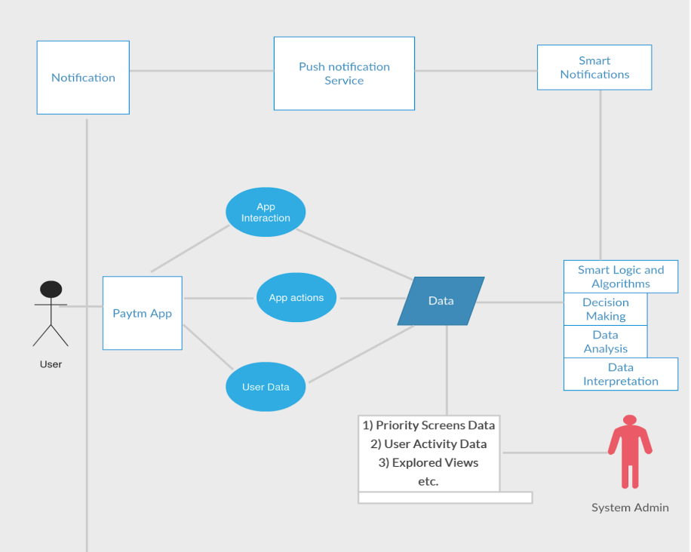

Figure 4.2.1

* This is a basic structure of the project where we are approaching a e-commerce platform here paytm is taken as an example the user interacts with the application and the app is set to go through in terms of data management as mentioned in the figure 4.2.1.
* The user receives notifications by push notification service in our project we have used SendPulse which send smart notifications which are customizable and ready-on-delivery.

**Deployment Diagram:**

Push notification server

E-commerce Web Server

Push notification

Subscription service

E-Commerce platform

(Cient-side Browser)

Figure 4.2.2

**Project Components:**

* HTML(Structure)
* CSS(Styling)
* Leaflet API
* Push Notification sender webservice
* (SendPulse)
* JavaScript(Web Integration)

**CHAPTER-5**

**OBJECTIVES**

* The scripting and design of the e-commerce store which consists of various design elements using CSS and good structure by HTML with an inclusion of API
* Successful integration of our e-commerce store to notification sending server platform with required code or links. Send notifications based on user preferences, using data analytics to target specific message
* Allow users to change their notification frequency selections to prevent receiving too many unwanted alert. To send swift push notifications that are not excessive or tiresome for the user which leads to user interest
* Understanding the market needs and trends to follow up on the customization of the notification that are sent to the e-commerce store as to increase user attractions. Allowing users to have a choice of what to receive and what not by giving a choice of getting push notifications or not

**CHAPTER-6**

**SYSTEM DESIGN & IMPLEMENTATION**

**6.1 System Design:**

**Frontend Design (HTML and CSS):**

* **Design responsive HTML and CSS templates for the car and motorcycle rental website.**
* **Create sections for automobile listings, search functionality, user registration/login, and booking forms.**

**User Authentication:**

* Create a user authentication system that includes HTML forms for user registration and login.
* Implement client-side validation, and securely manage user credentials.

**Car Listings and Booking:**

* Create HTML templates to display available cars with details (such as model, price, and availability).
* Create a booking form that allows users to select rental dates and make reservations.

**Responsive Design:**

* Ensure the website is responsive for optimal user experience on various devices (desktop, tablet, mobile)

**Mapping Inclusion (Leaflet API):**

* **Implement the Leaflet API to provide interactive mapping.**
* **Display automobile rental locations on a map, complete with markers and relevant information.**

**Website Integration with SendPulse:**

* Create an account with SendPulse to obtain API credentials.
* Use the SendPulse API to provide backend logic that sends email notifications for booking confirmations, reminders, and updates.
  1. **System Implementation:**

HTML and CSS Implementation:

* Code the HTML and CSS templates for the website, ensuring a clean and visually appealing design

Leaflet API Implementation:

* Integrate the Leaflet API into the website to display an interactive map
* Connect the frontend map to the backend API for dynamic data functions

User Authentication Implementation:

* Implement user registration and login functionality with appropriate verification
* Securely store user credentials and handle authentication periods

Car Listings and Booking Implementation:

* Implement booking forms and connect them to backend logic for reservation processing

Responsive Design Implementation:

* Ensure the website layout is accessible to different screen sizes and devices

SendPulse Email Integration Implementation:

* Use SendPulse and integrate your website with simple email integration

Testing:

* Conduct thorough testing of the whole system, including frontend functionality, mapping, user authentication, and email notifications

Monitoring and Maintenance:

* Set monitoring tools to conduct tracking of website performance
* From time-time update and maintain the system, addressing any issues that arise

**CHAPTER-7**

**TIMELINE FOR EXECUTION OF PROJECT**

**(GANTT CHART)**

**7.1 Timeline:**

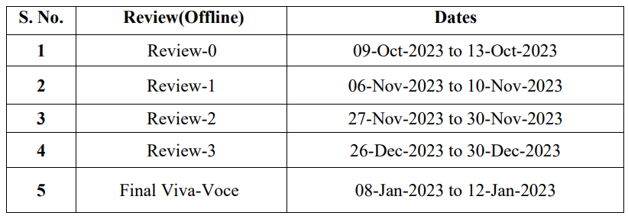

Table 7.1

**7.2 Gantt Chart:**

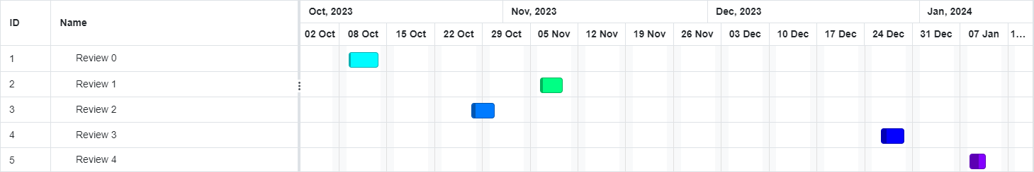

Table 7.2 (Given Gantt Chart)

**CHAPTER-8**

**OUTCOMES**

The outcomes of implementing the described system for a car rental website with Leaflet API and SendPulse integration are numerous and can significantly impact user experience, business efficiency, and communication effectiveness. Here are some expected outcomes:

Customer-Friendly Car Rental Platform:

* A well-designed and responsive user interface allows users to easily surf and book cars, enhancing the overall user experience.

Interactive Mapping Features:

* Integration of the Leaflet API provides an interactive map, allowing users to view car rental locations visually and plan their reservations efficiently.

Secure customer verification:

* A robust user authentication system ensures secure handling of user credentials and protects user accounts from unauthorized access.

Good Brand Image:

* A well-implemented and user-friendly platform, coupled with effective communication, contributes to a positive brand image and customer trust.

Push notification swiftly sent:

* A well customized push notifications can be sent with various images, emojis, 3d designs, text fonts, text animations, image animations etc.

**CHAPTER-9**

**RESULTS AND DISCUSSIONS**

Several benefits resulted from the construction of the automobile rental website, which used HTML and CSS for frontend design, Leaflet API for mapping, and SendPulse for email communication. An improved user experience was aided by the interactive maps, booking procedures that were simple to use, and user-friendly interface. Enhancing client interaction, SendPulse integration allowed for personalized and automatic email notifications.

The robustness of the platform was guaranteed via optional online payment integration and secure user authentication. Scalable and adaptable functionality was made possible by the modular design, which allowed for additions and modifications to satisfy changing market demands.

A dependable and efficient platform was maintained by ongoing maintenance and monitoring in addition to analytics-driven decision-making. Positive outcomes were noted in terms of a positive brand image, user satisfaction, and effective business operations.

Furthermore, SendPulse's connection for email communication adds a sophisticated level of personalization and automation. With the help of this function, the platform can automatically create and send customized email notifications, such updates, reminders, and booking confirmations. This improves client happiness and engagement while also streamlining the communication process.

During the conversation, these findings highlight how well the overall implementation met project goals and had a beneficial effect on many aspects of the platform. Going forward, maintaining the favorable results and guaranteeing the success of the vehicle rental website will require constant observation, analysis of user input, and strategic optimization.

**CHAPTER-10**

**CONCLUSION**

To sum up, the integration of HTML, CSS, the Leaflet API, and SendPulse has resulted in an outstanding success for the implementation of the auto rental website. The project's goals of improving user experience, expediting communication, and bolstering the platform's effectiveness were all accomplished with noteworthy success.

An easy-to-use and captivating interface has been produced by the integration of interactive mapping capabilities with a user-centric design. An overall pleasant user experience is enhanced by the ease with which users may see rental locations and research automobile possibilities. SendPulse integration allows for automatic and customized communication, resulting in timely and customized notifications that improve customer happiness and engagement.

Users are reassured and transactions are made easier by the platform's strong security features, which include secure user login. Integration sets up the platform for flexibility and scalability so it may change to meet the demands of the market.

For marketers, the increasing uninstall rate depending on the frequency can be an important basis to calculate the costs of a push notification. In practice, knowledge of the acquisition costs or the costs for an app install is necessary to do so which is why based on the regression analysis we have to make a user interface much more individual client based and not pop a hundred notifications without context.

To sum up, this automobile rental website's successful implementation demonstrates how well technology, user-centric design, and data-driven methods can be combined. With integration of a notification pushing webservice platform.

**REFERENCES**

[1]. Adamczyk, P. D., & Bailey, B. P. (2004). If not now, when? The effects of interruption at different moments within task execution. Proceedings of the SIGCHI Conference on Human Factors in Computing Systems, 271-278.

[2]. Wohllebe, A., Dirrler, P., & Podruzsik, S. (2020). Mobile Apps in Retail: Determinants of Consumer Acceptance – a Systematic Review. International Journal of Interactive Mobile Technologies (IJIM), 14(20), 153-164.

[3]. C-3PO: Click-sequence-aware Deep Neural Network (DNN)-based Pop-ups Recommendation I Know You’ll Click Ton Hsien-De Huang , and Hung-Yu Kao∗ Leopard Mobile Inc.(Cheetah Mobile Taiwan Agency), Taiwan

[4]. Automated Extraction of Personal Knowledge from Smartphone Push Notifications Yuanchun Li, Ziyue Yang, Yao Guo, Xiangqun Chen, Yuvraj Agarwal, Jason I. Hong., 2018

[5]. Breaking barriers to push notification engagement, Leanplum

[6]. Investigating Episodes of Mobile Phone Activity as Indicators of Opportune Moments to Deliver Notifications Joel E. Fischer, Chris Greenhalgh, Steve Benford The Mixed Reality Laboratory University of Nottingham.

[7]. The Effect of Implementing Web Push Notification and Customer Relationship Management in E-Commerce of Silver Craft MSME Heni SULASTRI , Putri Eka SEVTIYUNI , Alam RAHMATULLOH , Ni Made Karuni SANJIWANI.

[8]. Push Notification as a Business Enhancement Technique for E-commerce Arvind Kumar, Suchi Jobari Department of Computer Applications, Indus International University Una, Himachal Pradesh, India.

[9]. A Review Paper on E-Commerce Dr. Shahid Amin Prof. Keshav Kansana Jenifur Majid, Asst. Professor, ITM SOB, ITM University Gwalior. **Associate Professor, ITM SOB, ITM University Gwalior. ****PhD Scholar, The Business School, University of Kashmir

[10]. The impact of blockchain on e-commerce: A framework for salient research topics Horst Treiblmaier, Christian Sillaber

**APPENDIX-A**

**PSUEDOCODE**

// Define HTML document structure

htmlDocument {

// Head section

head {

charset = "utf-8"

meta("X-UA-Compatible", "IE=edge")

meta("viewport", "width=device-width, initial-scale=1.0")

title("Car and bike rental")

link("style.css", "stylesheet")

link("https://cdn.jsdelivr.net/npm/boxicons@latest/css/boxicons.min.css", "stylesheet")

link("https://cdnjs.cloudflare.com/ajax/libs/font-awesome/4.7.0/css/font-awesome.min.css", "stylesheet")

script("https://web.webpushs.com/js/push/5b03764a3882096936919cfae8a8f430_1.js", "charset=UTF-8", "async")

}

// Body section

body {

// Header section

header {

a(href="#", class="logo") {

img(src="rental logo.png", alt="")

}

div(class="bx bx-menu", id="menu-icon")

ul(class="navbar") {

li: a(href="#home", "HOME")

li: a(href="#ride", "RIDE")

li: a(href="#services", "SERVICES")

li: a(href="#about", "ABOUT")

li: a(href="map.html", "MAPS")

li: a(href="#reviews", "REVIEWS")

}

div(class="header-btn") {

a(href="signup.html", class="sign-up", "Sign Up")

a(href="signin.html", class="sign-in", "Sign in")

}

}

// Home section

section(class="home", id="home") {

div(class="text") {

h1: "Looking to rent a car or a motorcycle"

p: "We are one of the leading rental services of the city offering a sweet ride for your budget and assisting you through your journey."

div(class="app-stores") {

img(src="ios.png", alt="")

img(src="play.png", alt="")

}

}

div(class="form-container") {

form(action="") {

div(class="input-box") {

span: "Location"

input(type="search", placeholder="Search Places")

}

div(class="input-box") {

span: "Pick-up Date"

input(type="date")

}

input(type="submit", class="btn")

}

}}

// Ride sectio

section(class="ride", id="ride") {

div(class="heading") {

span: "Let's go!!!"

h1: "Rent with 3 easy Steps"

}

div(class="ride-container") {

div(class="box") {

i(class='bx bx-map')

h2: "Choose a location"

p: "Find a vehicle from wherever you are in the city"

}

div(class="box") {

i(class='bx bxs-calendar-star')

h2: "Pick-Up Date"

p: "Enter the date you want to get a ride."

}

div(class="box") {

i(class='bx bx-car') + '/' + i(class="fa fa-motorcycle")

h2: "Book A Vehicle"

p: "Decide your preferred vehicle: a car or a bike"

}

}

}

// Services section

section(class="services", id="services") {

div(class="heading") {

span: "Best Services"

h1: "Explore Our Top Deals From Top Rated Brands"

}

div(class="services-container") {

// Repeat for each service box

div(class="box") {

div(class="box-img") {

img(src="polo.jpg", alt="")

}

p: "2017"

h3: "'17 Volkswagen Polo"

h2: "Rs.9.23L | Rs.13500/month"

a(href="#", class="btn", "Rent Now")

}

}

// Repeat for other service boxes

}

// About section

section(class="about", id="about") {

div(class="heading") {

span: "About Us"

h1: "Explore Our Top Deals From Top Rated Dealers"

}

div(class="about-container") {

div(class="about-img") {

img(src="about.png", alt="")

}

div(class="about-text") {

span: "About Us"

p: "The rental company Tenet 2/4 was founded in 2016 by a group of engineers in Bengaluru prioritizing reliability and easy approach, suitable for the city's spontaneous growth and is now one of the leading vehicle rentals in the city."

a(href="#", class="btn", "Learn More")

}

}

}

// Reviews section

section(class="reviews", id="reviews") {

div(class="heading") {

span: "Reviews"

h1: "Look what our customer say"

}

div(class="reviews-container") {

// Repeat for each review box

div(class="box") {

div(class="rev-img") {

img(src="pexels-italo-melo-2379005.jpg", alt="")

}

h2: "Ayaan A"

div(class="stars") {

i(class='bx bxs-star')

i(class='bx bxs-star')

i(class='bx bxs-star')

i(class='bx bxs-star-half')

}

p: "Even though we have only two bikes available on the website, my friend and I picked both. I rode the xpulse which was in great condition. The cb35rs held on swiftly on highways. I had some issues with the handle which was shaking."

}

}

// Repeat for other review boxes

}

// Newsletter section

section(class="newsletter") {

h2: "Subscribe To Newsletter"

div(class="box") {

input(type="text", placeholder="Enter Your Email...")

a(href="#", class="btn", "Subscribe")

}

}

// Copyright and Social section

div(class="copyright") {

p: "© Tenet Rentals All Right Reserved"

div(class="social") {

a(href="#"><i class='bx bxl-facebook'></i></a>

a(href="#"><i class='bx bxl-twitter'></i></a>

a(href="#"><i class='bx bxl-instagram'></i></a>

}

}

}

}

**SendPulse integrated using:**

<script

charset=”UTF-8"src="//web.webpushs.com/js/push/5b03764a3882096936919cfae8a8f430_1.js" async></script>

**APPENDIX-B**

**SCREENSHOTS**

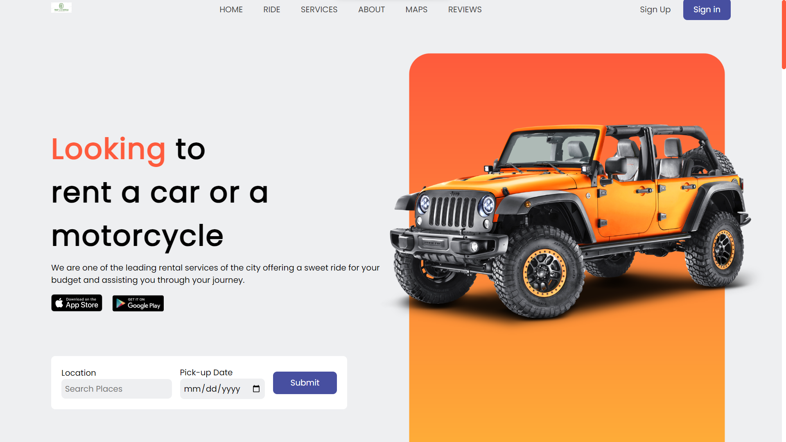

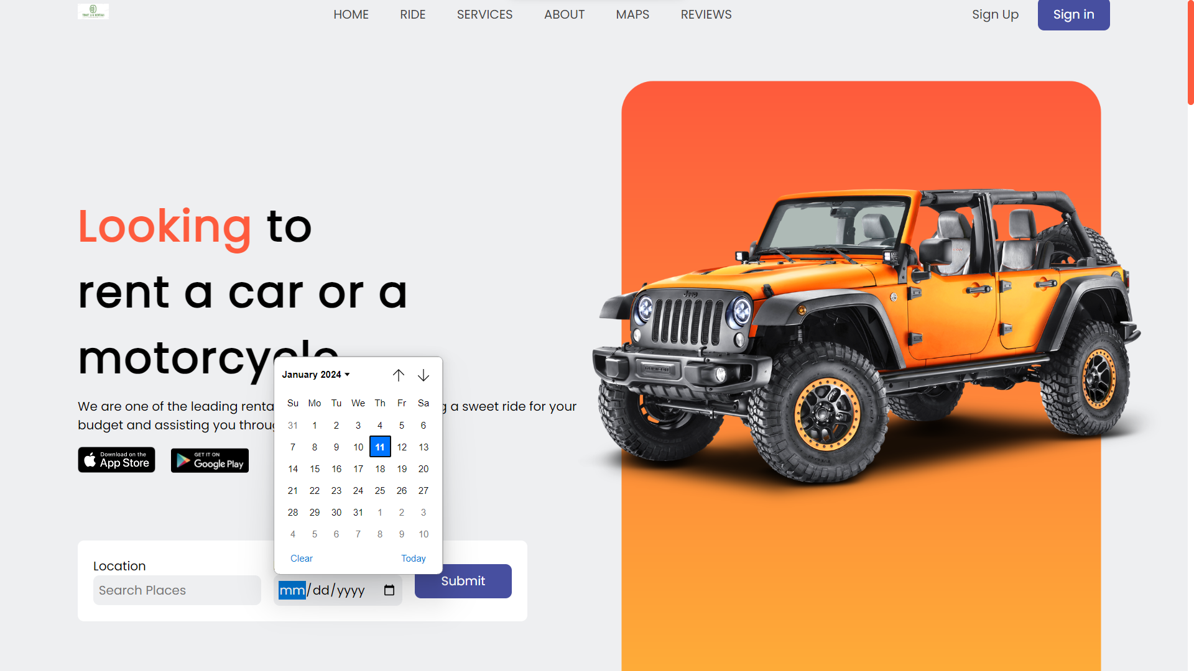

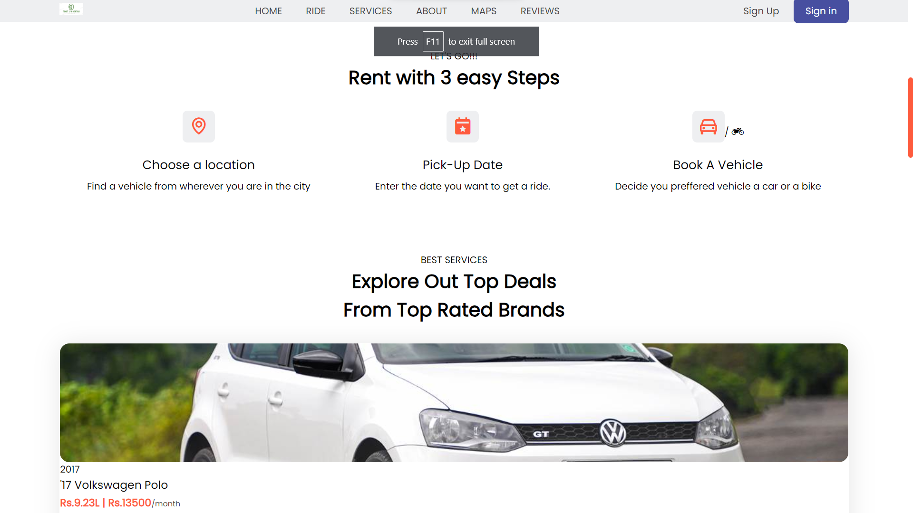

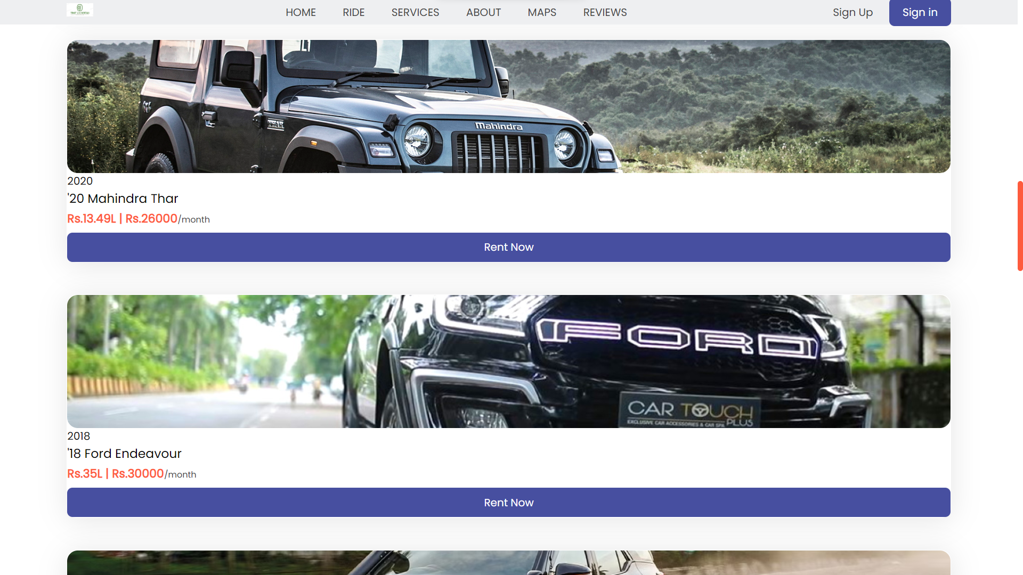

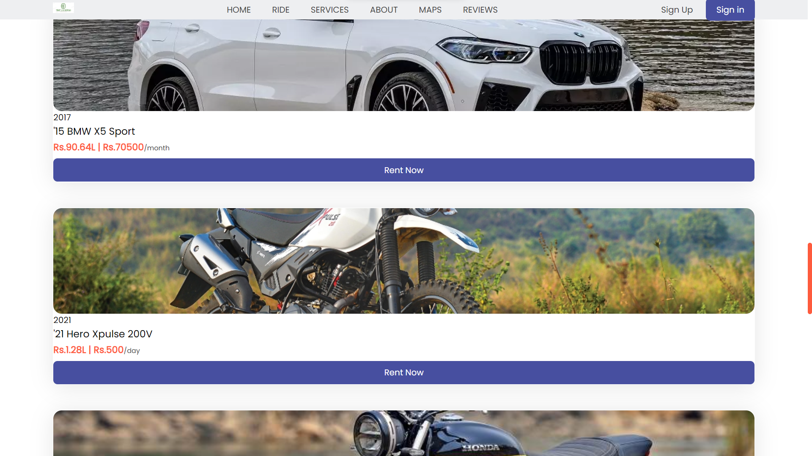

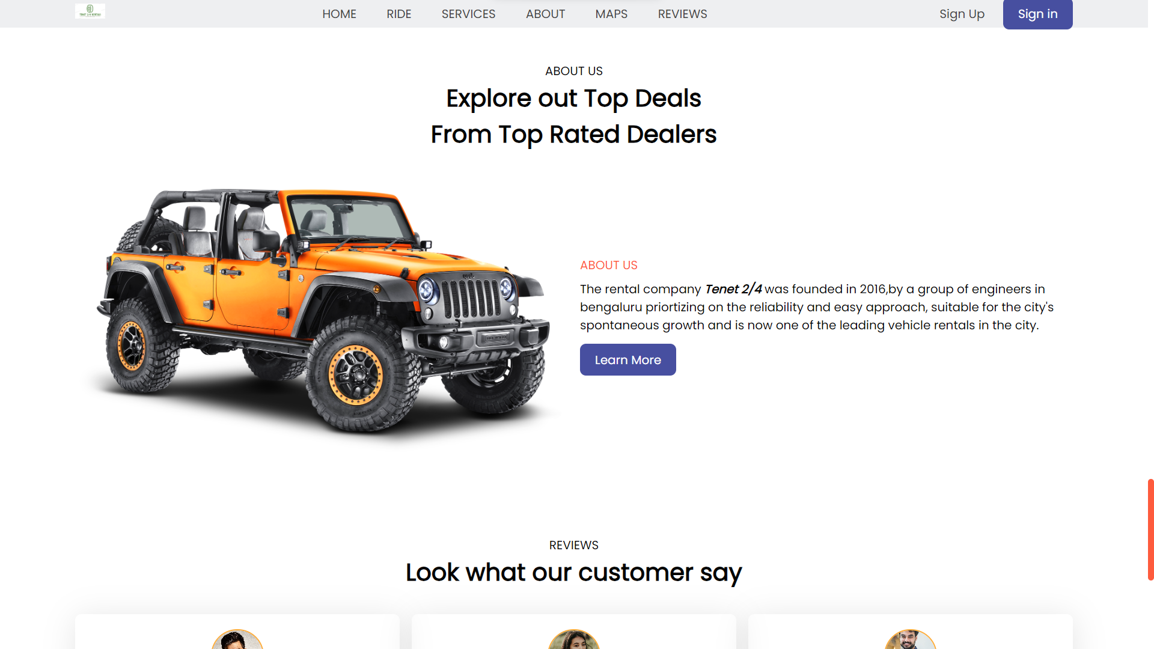

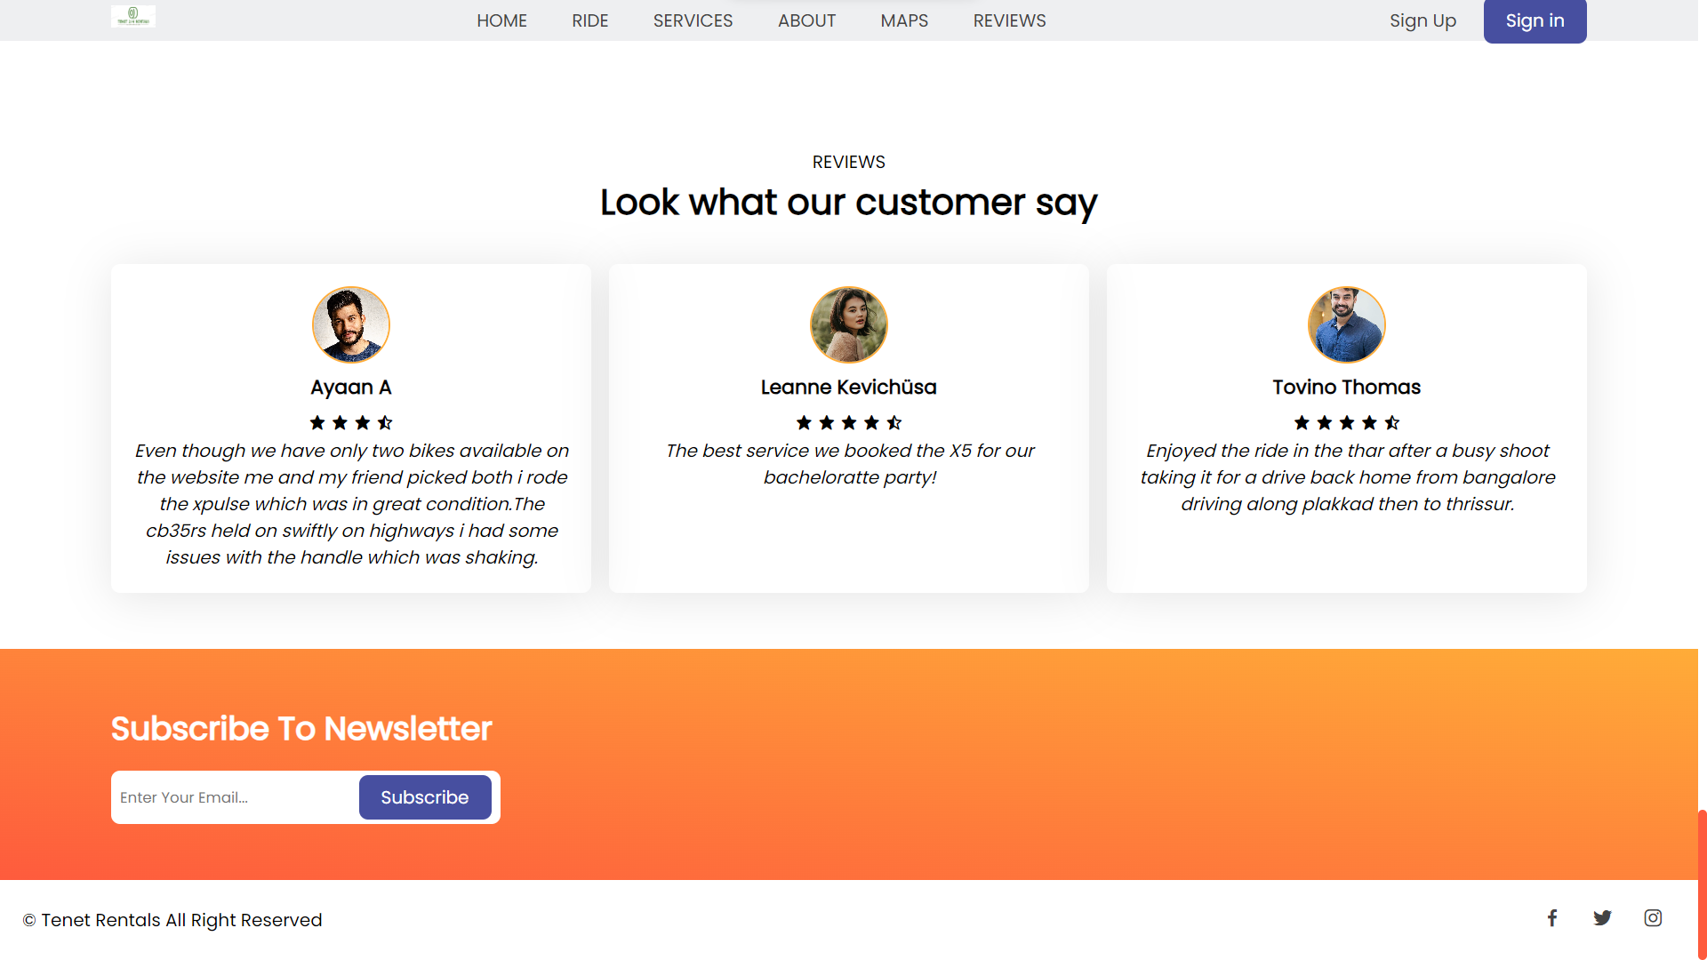

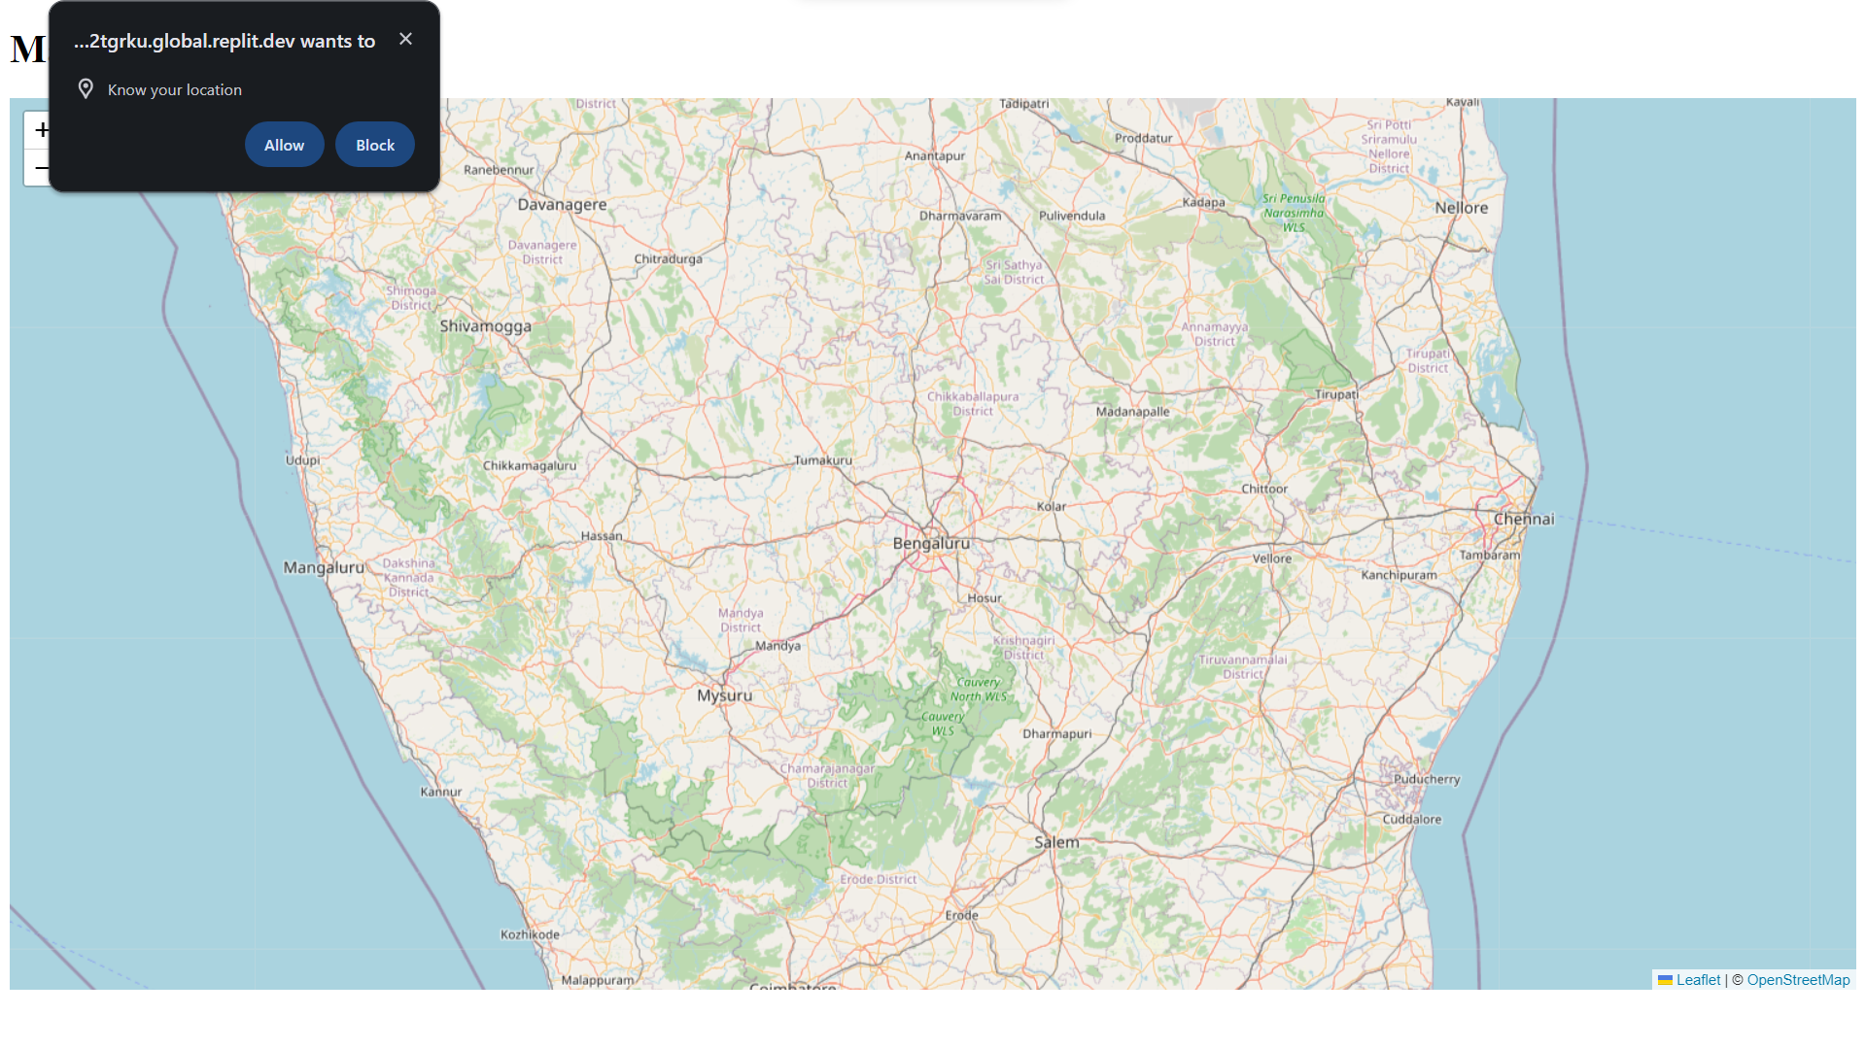

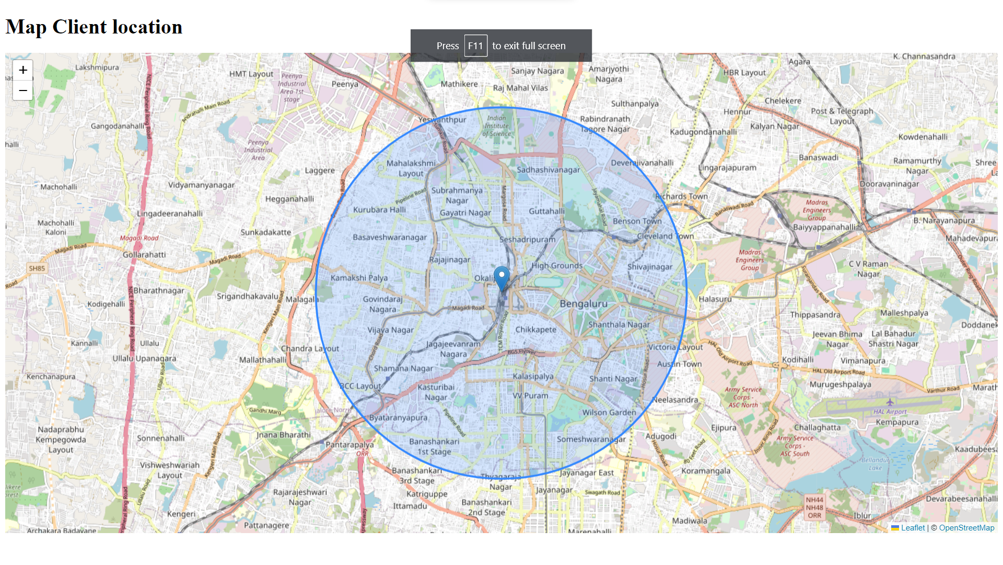

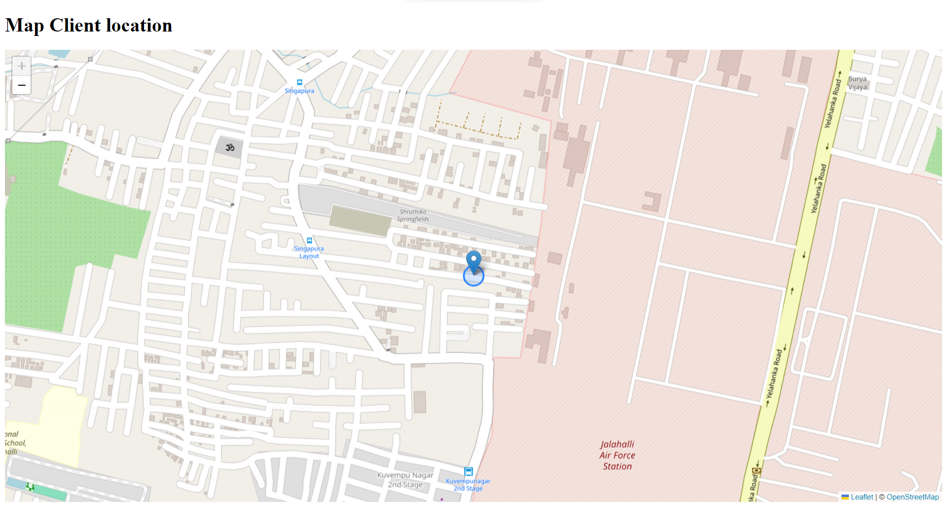

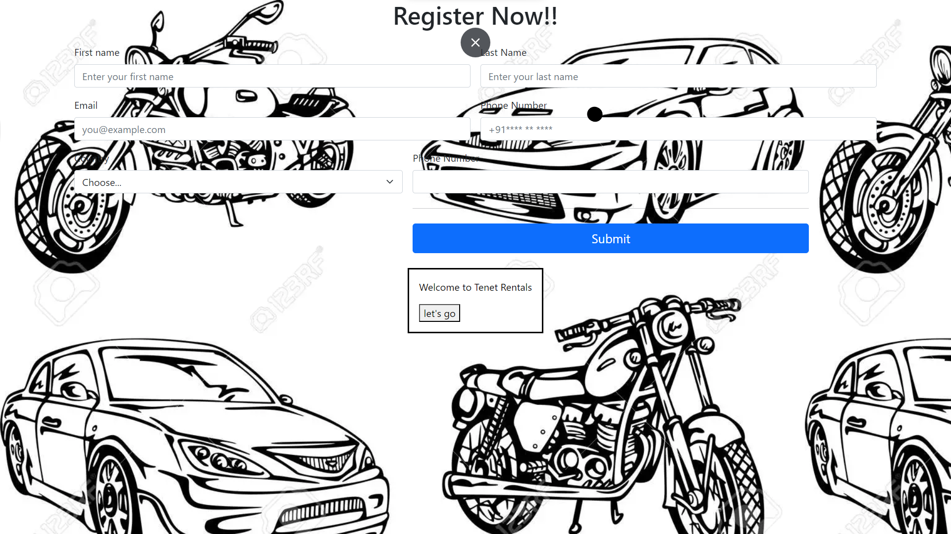

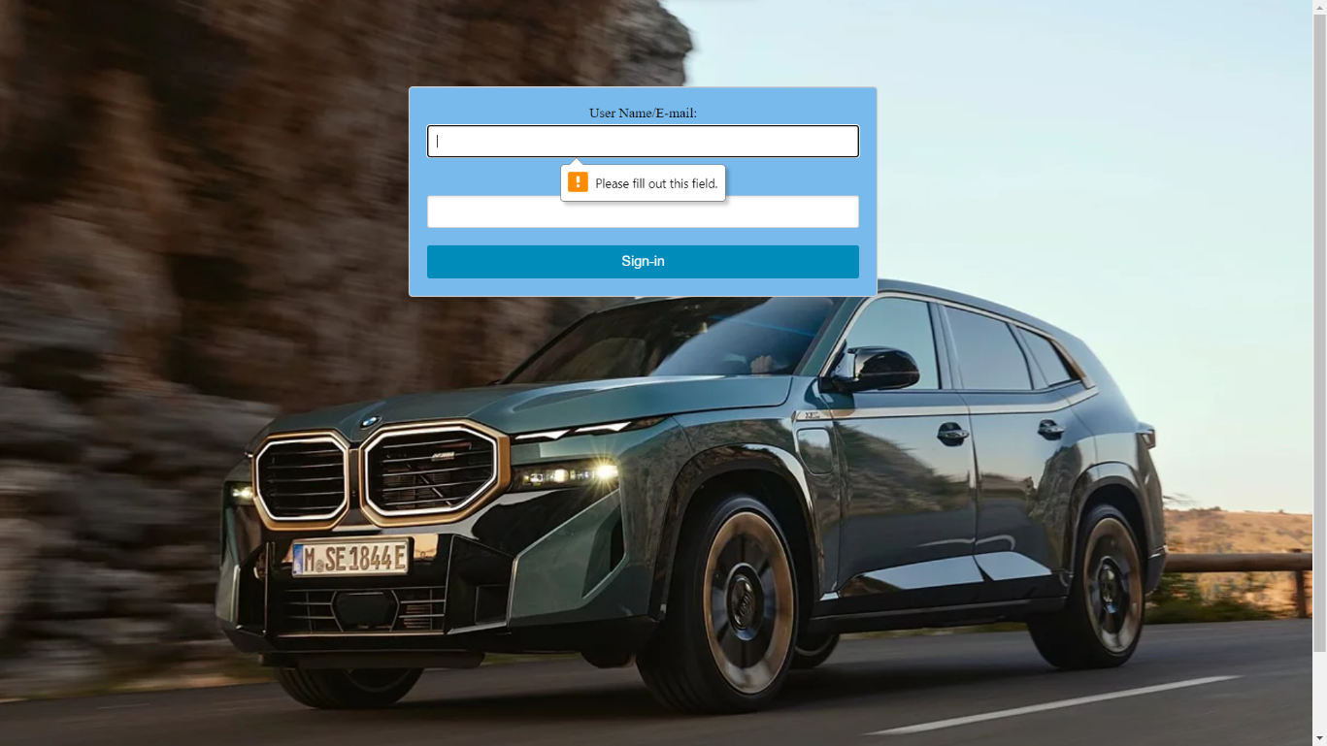

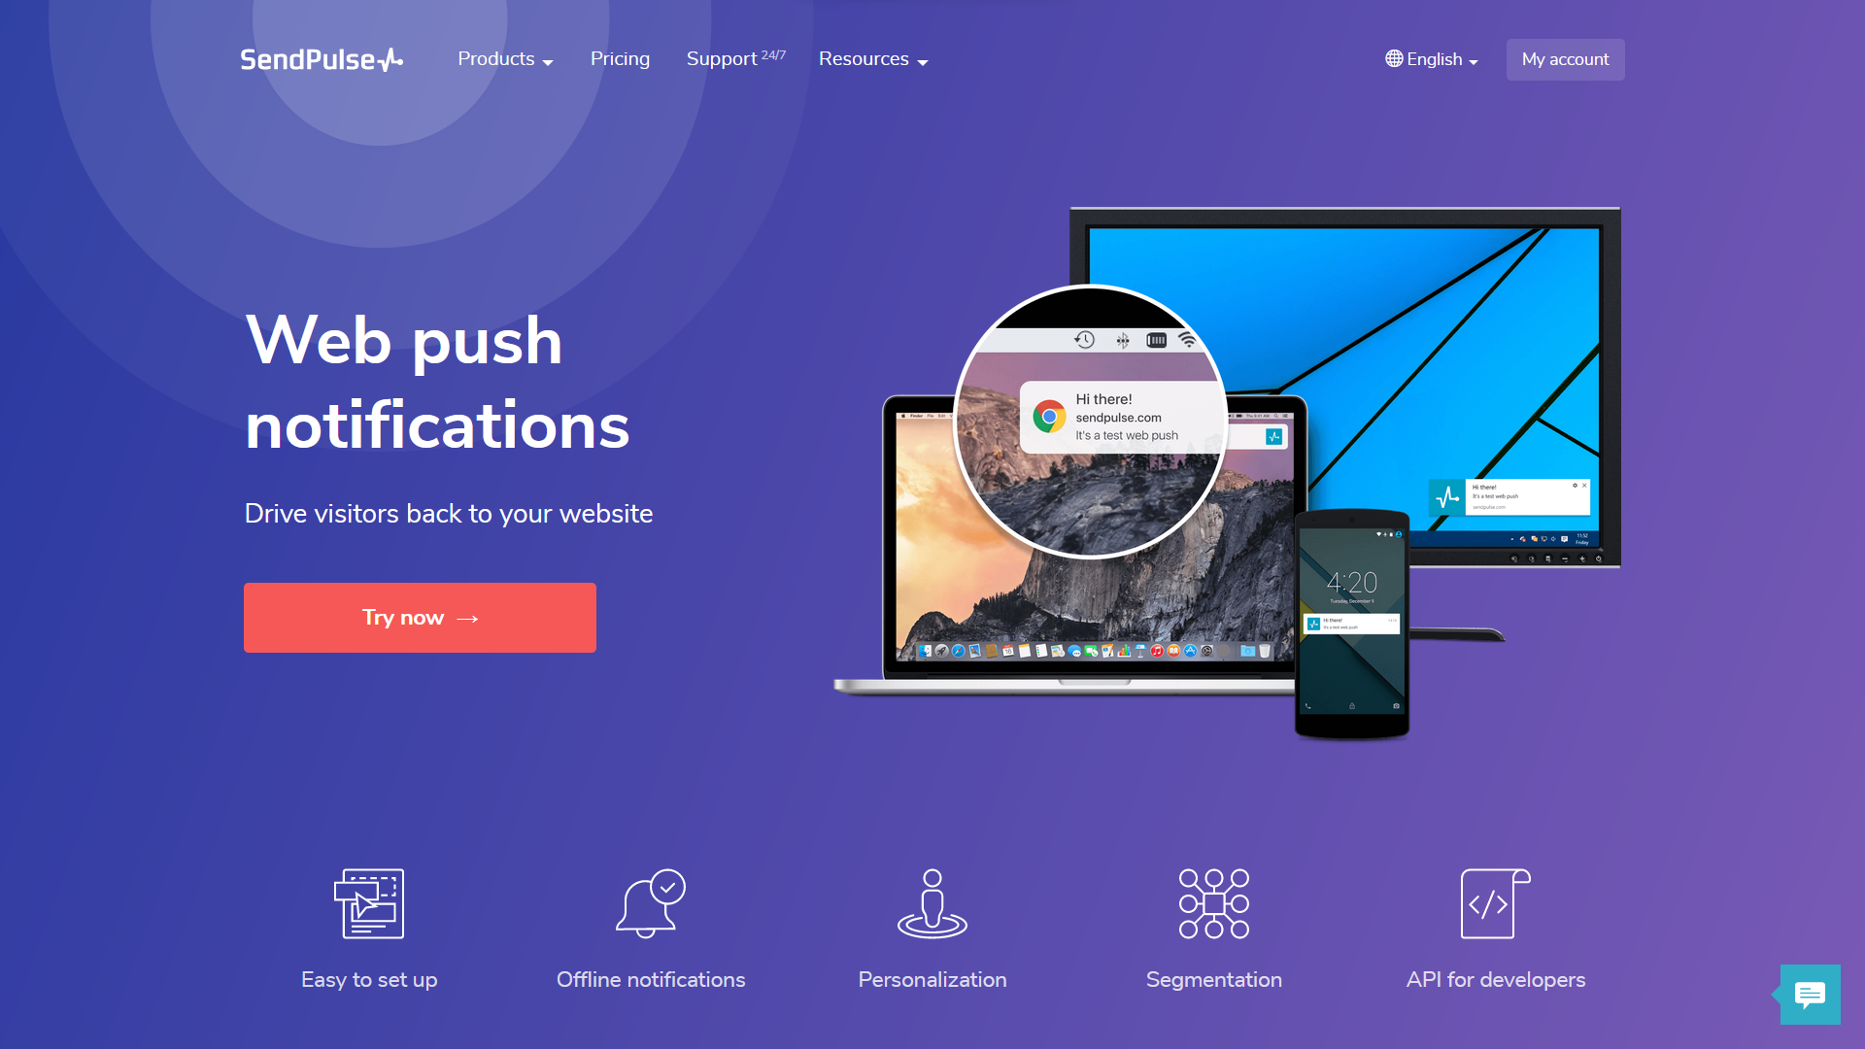

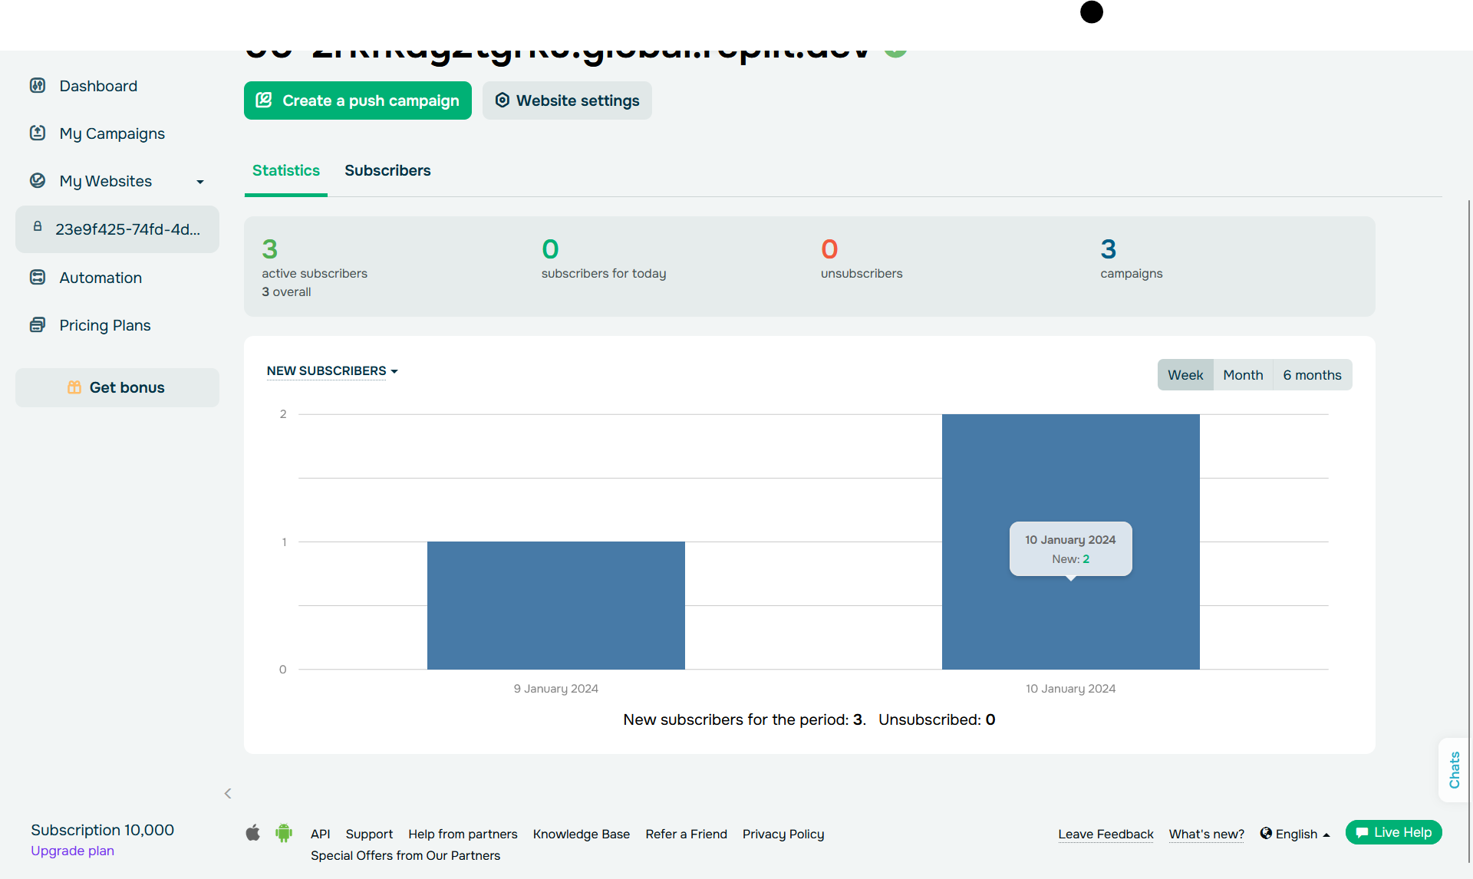

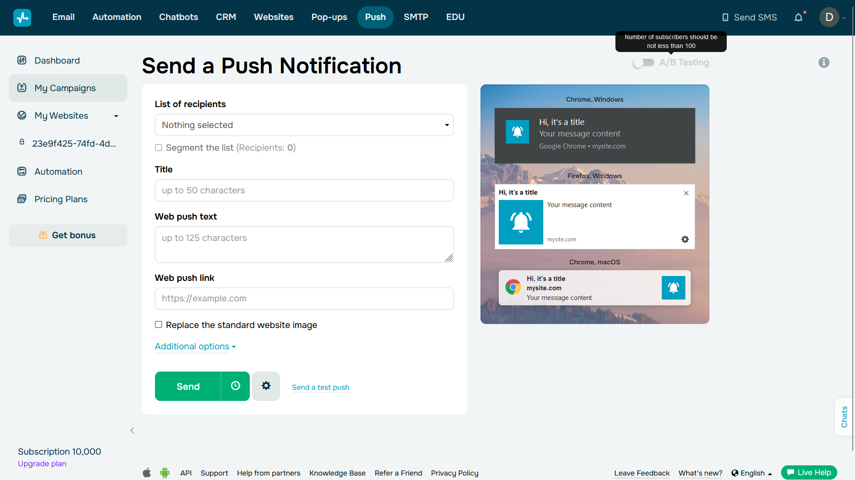

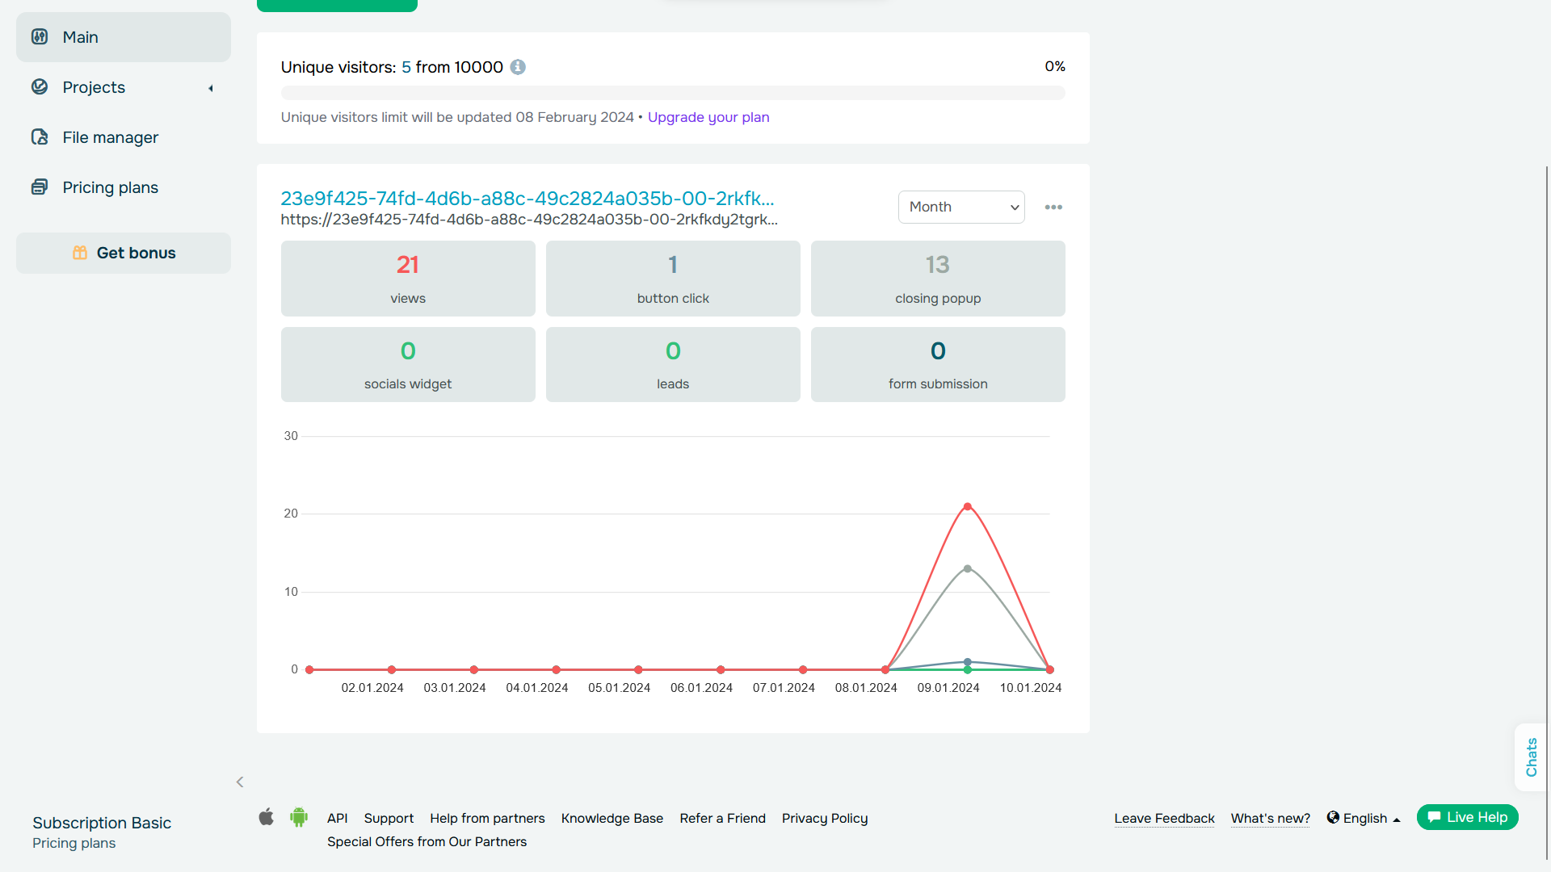

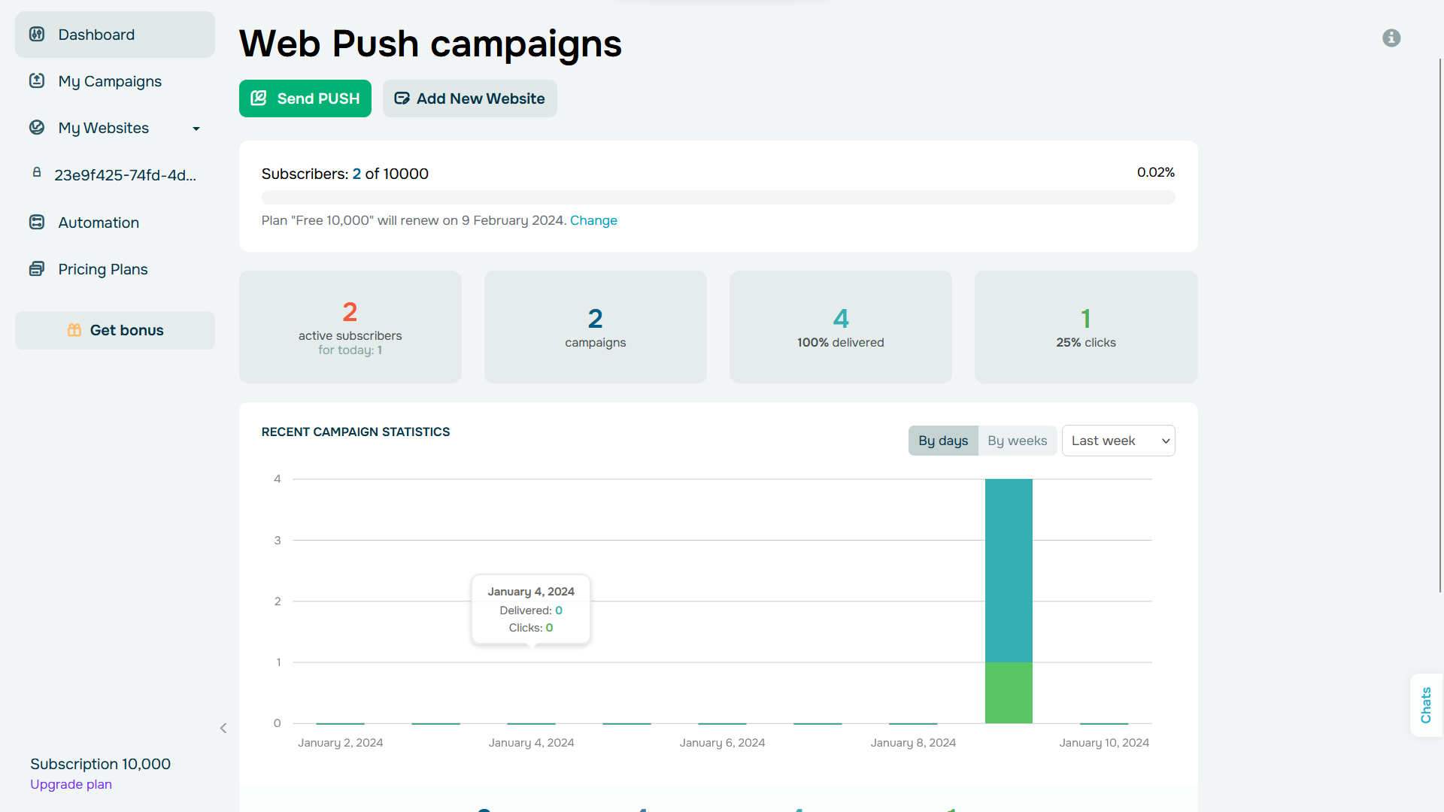

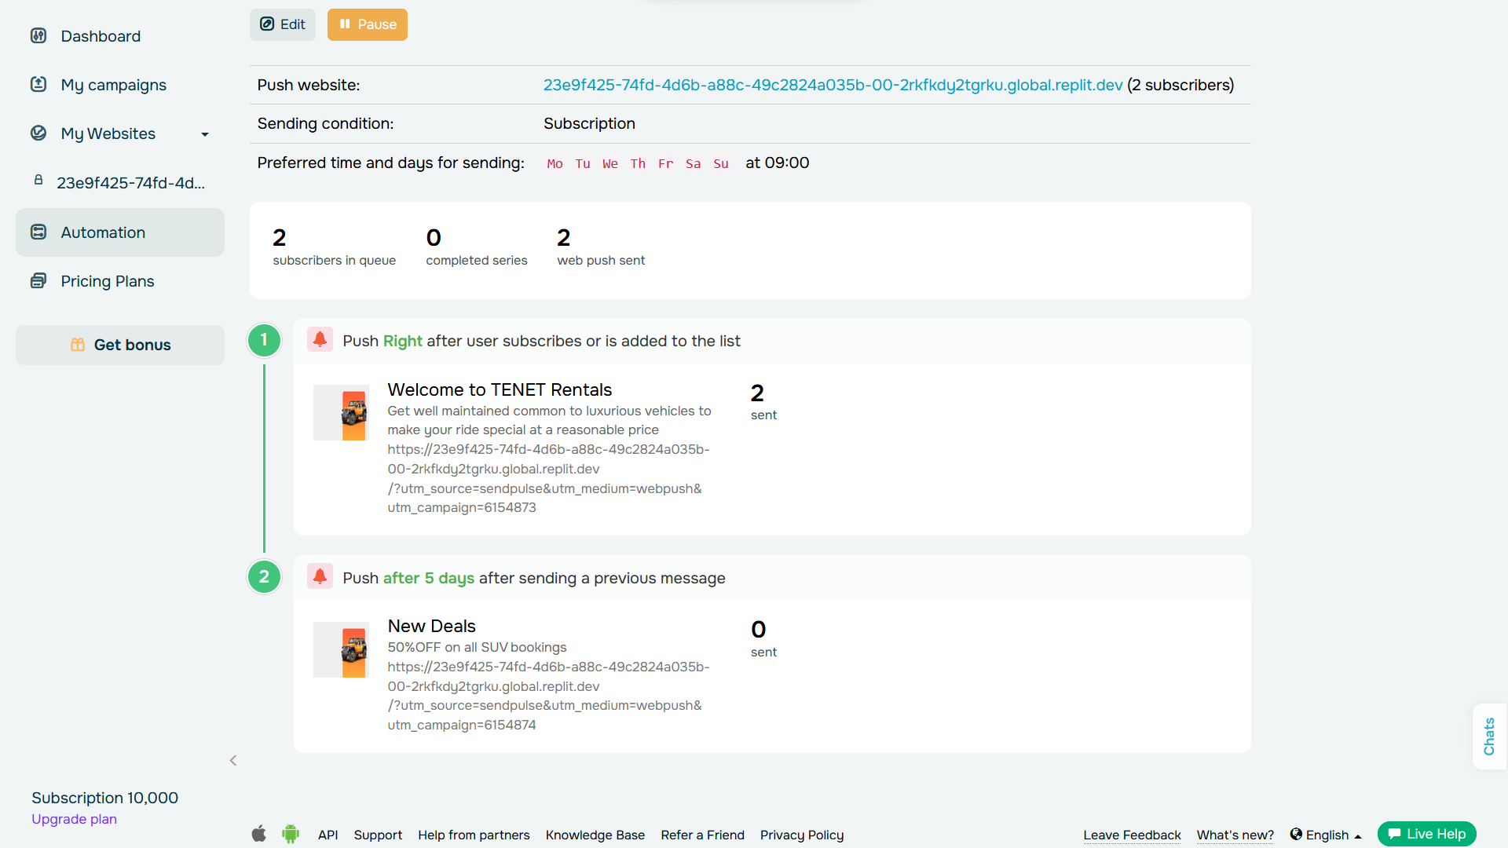

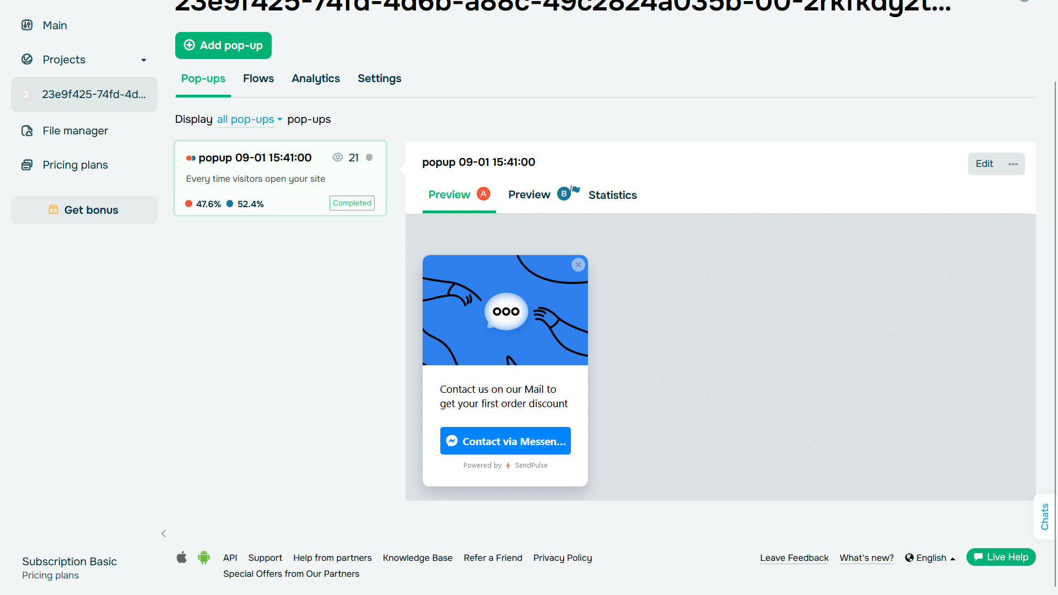

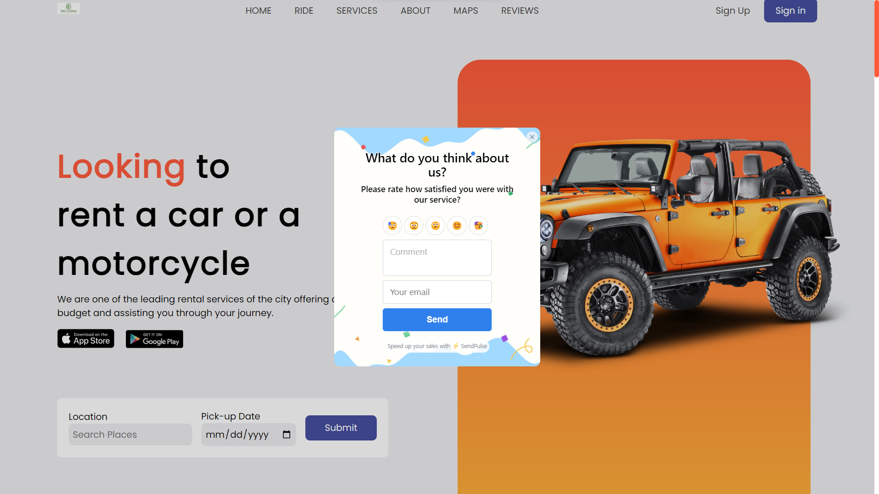

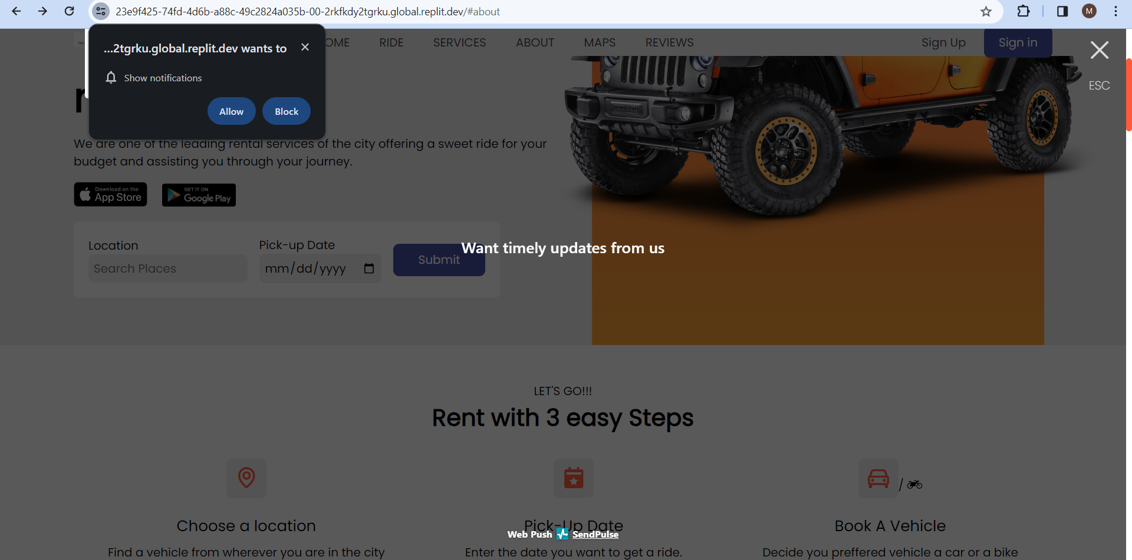

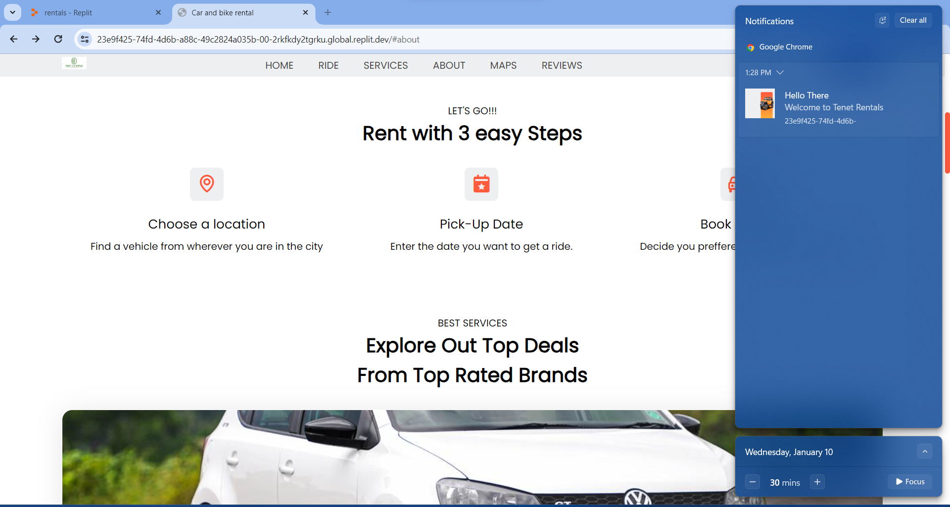

**APPENDIX-C**

**ENCLOSURES**

**PLAIGARISM REPORT:**

**APPENDIX-D**

**SD-3**

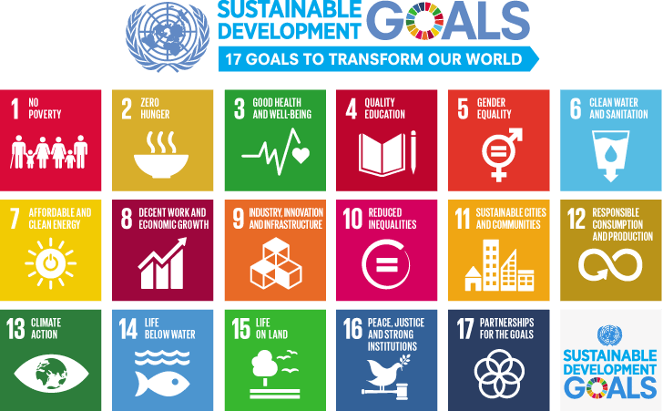

**The Project work carried out here is mapped to SDG-3 Good health and well being**

The project carried out here also contributes human health and well-being. Mental health being very vital in this generation, constant usage of applications is quite common but excessive notification at unproperly times may cause irritation at very sensitive level it may look minor but can be major for some users minimizing it may relieve that issue for a more calmer being.